CHAPTER 1

INTRODUCTION

Fingerprint recognition technology allows access to only those whose fingerprints that are pre stored in the memory. Stored fingerprints are retained even in the event of complete power failure or battery drain. These eliminates the need for keeping track of keys or remembering a combination password, or PIN. It can only be opened when an authorized user is present, since there are no keys or combinations to be copied or stolen, or locks that can be picked. The fingerprint-based lock therefore provides a wonderful solution to conventionally encountered inconveniences. This report focuses on the use of fingerprints to unlock locks, as opposed to the established method of using keys. In order to prevent unauthorized access to these devices, passwords and other pattern-based authentication method are being used in recent time. However, password-based authentication has an intrinsic weakness in password leakage. While the patterns are easy to steal and reproduce. In this paper, we introduce an implicit authentication approach that enhanced the password pattern with additional security layer. Biometric systems have overtime served as robust security mechanisms in various domains. Fingerprints are the oldest and most widely used form of biometric identification. A critical step in exploring its advantages is to adopt it for use as a form of security in already existing systems, such as vehicles.

**CHAPTER 2**

**LITERATURE SURVEY**

**2.1. Self Bike Stater Using Arduino**

**Author:** Sayantam Sadhukhan, Aritra Acharya, and Rajendra Prasad (2017)

The method describe the relevance of IoT with mobile applications in their essay “ Car Security System employing Fingerprint Scanner and IOT” , released in Indian Journal of Science and Technology. They go on to say how crucial it is to maintain our automobiles as safe as we maintain our cell phones. The team discusses how to utilize a biometric auto entry system to keep your vehicle safe. It only permits numerous people totalize the automobile if they have been given permission. The employment of a mobile application is advantageous in this case. When the automobile is robbed, it sends a notification to the owner. Rajeev Velikkal (2019) outlines the demonstration of a keyless automobile entry system in his project, which was published in the Indian Journal of Science and Technology. He created this unit with the help of an Arduino kit, which he drew and programmed. Simple programming languages are used to create the design. As per a 2013 research paper titled "Fingerprint based locking system," the author created this work specifically to increase the bike's safety. The objective of this work is to investigate and comprehend the notion of the Fingerprint Module. Fingerprint Unit, Relay, Buzzer, and Arduino Module are all used in this application. The proposal also employs the usage of a buzzer as a signaling device. The owner of the bike can add or remove fingerprints, permitting or disallowing anyone to ride the motorcycle.

**2.2. Fingerprint Starter Vehicle Using Arduino**

**Author:** Pratiksha Jadhav, Nadira Mulla, Namrata Sutar, Sakshi Mane, S. H. Mali

Frequent locking of the vehicle does not adequately protect the vehicle owner. By providing easy access to the vehicle's functional systems, biometric systems can be used to reduce the risk of theft or robbery. Each person's fingerprint is unique, so it can be used in a variety of security options. These systems activate data using algorithms for specific results, usually based on positive identification of the user or others. Arduino generates the signal in the corresponding module circuit. Tags: fingerprint mode, Arduino, GSM mode, relay.

**2.3. Vehicle stater and theft control using GPS**

**Author:** ARUN BATI, SRUSHTI .V, PRIYANKA, AKASH R4 , , Prof. GAGANAMBHA5.

Fingerprints are amongst the oldest and most changed biometric systems, and they are frequently employed in biometric forms of identification. Vehicle safety has become a serious problem as the frequency of crime has increased. Vehicle keys are a big concern these days since they are easily forgotten or lost when carried. A system that uses a fingerprint authentication method to start a car. The operator can use the fingerprint reader to start the car with this technology. At start, this technology lets the customer to authenticate by scanning their unique fingerprint. To start the car, they might register several fingerprints. When a user scans their fingerprint in monitoring mode, if the framework does not recognize or memorize the fingerprint, or if the unknown person scans, the device alerts the security and turns off the ignition by having turned off the petrol nozzle in the event of a breach using GPS when the IC is relocated by an unrecognized user. This providesa safe and worry-free way to begin the engine or automobile. This is due to the system's usage of an ATmega 328 microcontroller, which includes an LCD screen, as well as pushbuttons and a starting motor. Another potential is a seamless and quick start for an identifiable user.

**2.4. Vehicle security system using Arduino**

**Author:** Abhilash Mudpe, Gauravi Narote, Mahendra Mahale, Priyanka Arshanapelli, Ms. Priyanka Kothoke.

There have been a lot of vehicle thefts andrecovering of these vehicles is a big headache both for the owner as well as the police authorities. Thieves use different techniques to change the vehicle’s appearance as well as using different parts of the vehicle and selling it and so on. So we aim to design a system that will give additional level of security to the owners thus preventing theft. This can be done by making sure that only the persons approved by the owner gets access to the vehicle and also the owner should be notified by the use of hidden techniques that the vehicle has been accessed by means of some physicaldamage.

**2.5. Vehicle ignition system using Arduino**

**Author:** Jamil Abedalrahim Jamil Alsayaydeh, Win Adiyansyah Indra, Adam Wong Yoon Khang, VadymShkarupylo and Dhanigaletchmi A. P. P. Jkatisan.

This paper is about building a prototype of vehicle ignition using fingerprint sensor. This system can prevent thevehicles from being stolen. It is developed to control the ignition of the vehicle through the fingerprint scanner. Thissystem consists of GSM SIM 900 that connects to the Arduino which is the microcontroller of the project. To make surethe system is secure, only authorized fingerprint is paired with the Arduino to start the ignition. Vehicles ignite when theenrolled fingerprint is matched against the fingerprints in the database while users with no match in the database areprevent from igniting the vehicle. A theft alarm from buzzer, a notification to the owner’s mobile phone via GSM SIM 900and status display in the LCD are the appropriate signal to the owner. This article describes briefly in detail about the design and implementation of the ignition system.

**CHAPTER 3**

**EXISTING SYSTEM**

In this project, we will be Interfacing Fingerprint Sensor with Arduino to design Fingerprint Sensor Based Self Bike Starter using Arduino. The type of fingerprint module we are using is the R305 Fingerprint Scanner Module. Security is a major concern in our day-to-day life, and digital locks have become an important part of these security systems. Fingerprint sensor-based is one of the safest bike starting systems as it has the ability to identify and distinguish every person individually without making any error. Also, the module is very small that it can be kept anywhere, and with the portability feature and less power consumption, you can carry it to any place as well. While biometrics and fingerprint identification has been existing for well over 100 years in some basic form, it is the growth of maker community that made the R305 Fingerprint Module so popular. R305 is a common module used fingerprint scanners, with the aid of a powerful DSP in its core. We can communicate with it using a packet of hex codes in a specific format.

# CHAPTER 4

# 

# PROPOSED SYSTEM

# The Proposed system consist of both hardware and software requirements. It consists of Arduino UNO, Power supply, Capacitive touch sensor, Motor driver and DC Motor as shown in the Figure4.1. Block diagram of proposed system.

# 4.1 BLOCK DIAGRAM

|  |
| --- |
| POWER SUPPLY |

|  |
| --- |
| LCD |

|  |
| --- |
| ARDUINO UNO |

|  |
| --- |
| DC  MOTOR |

|  |
| --- |
| CAPACITIVE TOUCH SENSOR |

**Fig 4.1. Block Diagram of Proposed System**

**4.2 POWER SUPPLY**

The operation of power supply circuits built using filters, rectifiers and then voltage regulators. Starting with an AC voltage, a steady DC voltage is obtained by rectifying the AC voltage, then filtering to a DC level, and finally regulating to obtain a desired fixed DC voltage. The regulation is usually obtained from an DC voltage regulator unit, which remain the same if the input DC voltage varies or the output load connected to DC voltage changes. A diode rectifier that provides a full-wave rectified voltage that is initially filtered by a simple capacitor filter to produce a DC voltage. A regulated circuit can use this DC inputs to provide a DC voltage that not only has much less ripple voltage but also remains. The same DC value even if the input DC voltage varies somewhat or the load connected to the output DC voltage changes this voltage regulation is usually obtained using one of a number of popular voltage regulation IC unit. In this circuit 230v AC is given as input to the primary windings of the transformer, which step-down’s the 230v into 12v Ac supply as shown in the Figure 4.2.

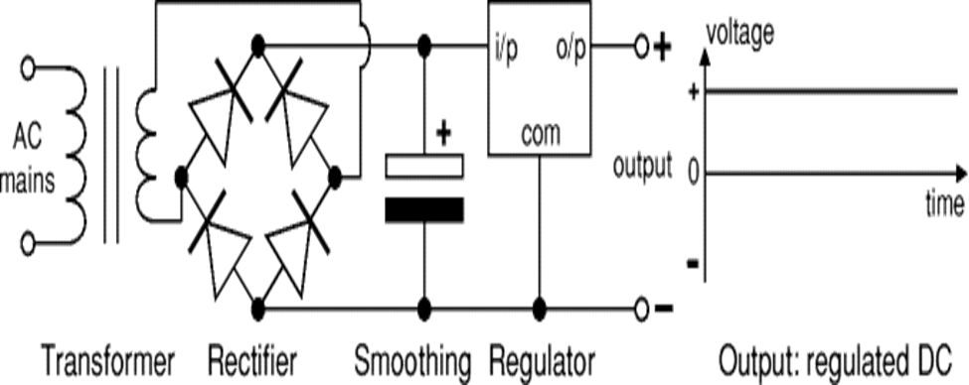

**Fig 4.2 Power supply**

**4.3 ARDUINO UNO**

Arduino is an open-source platform used to create electronic projects. Arduino consists of a physically programmable circuit board and an integrated development environment (IDE) running on a computer and is used to write the computer code and load it on the physical board. There is a good reason why the Arduino platform has become so popular with newcomers to electronics. Unlike most previous programmable circuits, Arduino does not require any additional hardware (called a programmer) to download the new code to the board. Just use a USB cable. Arduino also uses a simplified version of the IDE C ++ language, which makes programming easier to learn. Finally, Arduino offers a standard form factor that breaks down ARDUINO functionality into usable packages. Arduino hardware and software are designed for artists, designers, amateurs, hackers, beginners, and anyone interested in creating interactive objects or environments. Arduino can communicate with buttons, LEDs, motors, speakers, GPS devices, cameras, internet and even a smartphone or TV. This flexibility, the Arduino software is free, the hardware boards are quite cheap and both the software and the hardware are easy to learn, which resulted in a large community of users that included published code and instructions for a wide range of versions as shown in the Figure 4.3.

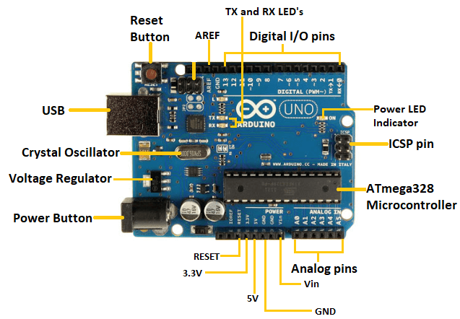

**Fig 4.3 Arduino UNO**

**4.4 CAPACITIVE TOUCH SENSOR**

Using the properties of capacitors, touch can be used as an extremely effective method of input and control. The two main uses for capacitive touch sensors in commercial products today are a simple switch and multi-touch input, such as a tablet PC or an iPhone. What allows the human body to be sensed are the conductive electrolytes that it contains, which allows charge to be held and transferred. A parallel-plate capacitor consists of two conductive layers of material with an insulating material called the dielectric in between them. Figure 4.4 shows the parallel plate capacitor formed by a finger and the copper traces of the sensing pad, with the glass overlay as the insulating dielectric. Charge exists in the finger as conductive electrolytes and in the copper traces from a constant current being applied to it. The net difference in charge between the finger and the copper traces is what creates capacitance. The detection of this capacitance is the main operating principle in capacitive touch sensing.

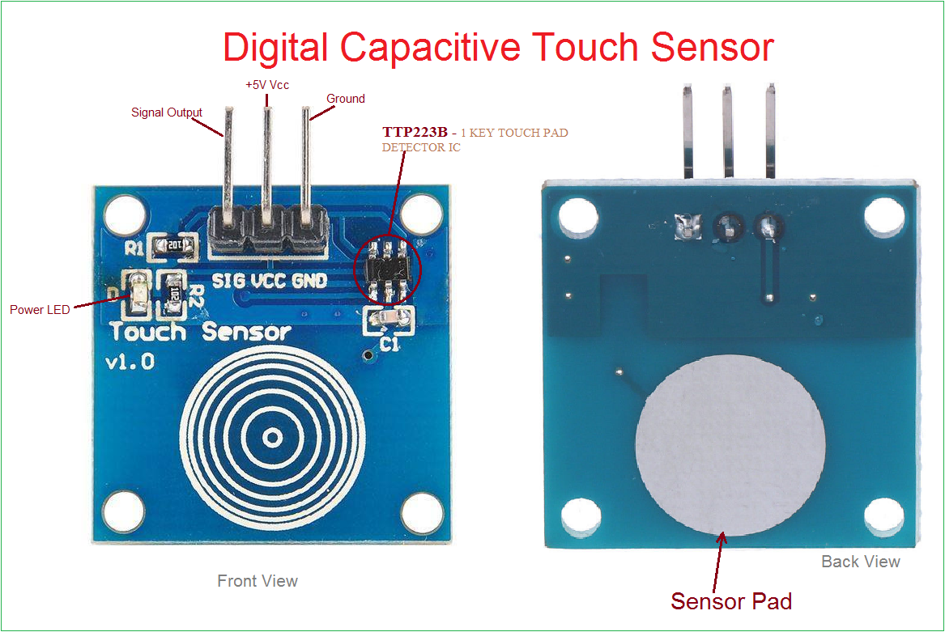

**Fig 4.4 Capacitive Touch Sensor**

**4.5 DC MOTOR**

 DC motor is an electrical machine that converts electrical energy into mechanical energy. In a DC motor, the input electrical energy is the direct current which is transformed into the mechanical rotation. In this session, let us know what is a DC motor, types of DC motor and their applications. A simple DC motor uses a stationary set of magnets in the stator, and a coil of wire with a current running through it to generate an electromagnetic field aligned with the centre of the coil. One or more windings of insulated wire are wrapped around the core of the motor to concentrate the magnetic field. In our project, DC Motor is the output device which can be run when the authorized person finger is scanned in the sensor as shown in the Figure 4.5.

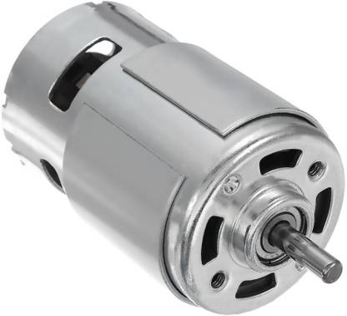

**Fig 4.5 DC Motor**

**CHAPTER.5**

**EXPERIMENTAL PROCESS**

The experimental process of our project consists of two steps, they are;

1. Interfacing of Arduino UNO.
2. Authentication process.

**5.1 INTERFACING OF ARDUINO UNO:**

Add Fingerprint sensor

Initialize the program using software by adding the authenticated person’s fingerprint

Add the DC Motor and channel relay as Output device

**Fig. 5.1 Interfacing of Arduino uno:**

**5.2 AUTHENTICATION PROCESS:**

Scan the finger using sensor(R305)

IF (Authenticated finger)

NO

YES

DC Motor starts

Relay/Buffer create a warning sound

**Fig. 5.2** **Authentication process**

**5.3 SIMULATION OF VEHICLE STARTER USING ARDUINO UNO**

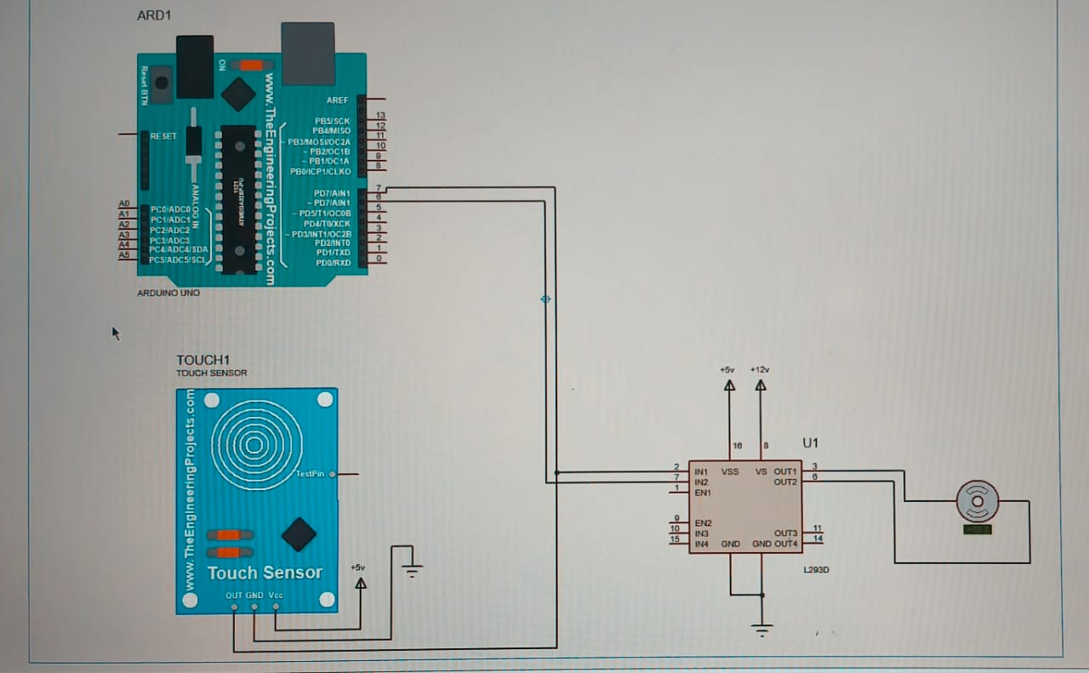

**Fig 5.3 Simulation of vehicle starter using Arduino UNO**

**CHAPTER 6**

**CONCLUSION**

This work is a well operating prototype of a fingerprint-based vehicle staring system. The system intelligent agents were able to communicate well and appropriate output is given under user input. The system requests for user’s finger, process it and give appropriate output based on if the finger is stored in the fingerprint module or not. The system is also able to enroll new user’s finger at request but prompt for passcode before it could be done. Passcode editing can also be done on request in the system. Hence, fingerprint technology improves the security of an automobile making it possible for the car to be used by only authorized users. Therefore implementing this system on vehicles makes the achievement of our car security system comes in a cheap and easily available form. The output is viewed with the use of an LED. Biometric recognition systems present security and convenience than conventional methods of personal recognition.

**REFERENCES**

[1]. Ajinkya Kawale, “Fingerprint-based locking systems”, International Journal of Scientific and Engineering Research, Volumul 4, № 5, pp.899-900, mai-2013.

[2]. Omidiora E.O. Pacoluzo OA Arulokun is an O.T. kk Aborisade D. O, “Prototypes of automotive fingerprint ignition systems”, European Journal of Scientific Research, Volume 62, №2, p. 164-171,2011.

[3]. Karthikeyan „VINGERAFDRUK GEBASEERD ONTSTEKINGSSYSTEEM” International Journal of Information / ISSN: 2250-3005.

[4]. Rushikesh Vallakati, Ruturaj Kavitke, Rushikesh Deokar, Paresh Savale, prof. R. G. Zhanunkar "Fingerprint Ignition Systems and Keyless Access via Fingerprint" International Journal of Innovative Research in Engineering and Synthetic Physics, Volume 9, 2349-7300, 4, 2021.

[5]. Dr.V.Nandagopal, Dr.V.Maheswari, C.Kannan, International Journal of Pure and Applied Mathematics, Transit Initiation Systems, Vol 119, 1753-1760, 2018.[8].

[6] Omidiora E. O., Fakolujo O. A., Arulogun O. T.,Aborisade D. O. 2011. A Prototype of a Fingerprint Based Ignition Systems in Vehicles. 62(2): 164-171.

[7] Kumar B. S. and Engineering I. 2017. Vehicle Anti-Theft System Using Fingerprint Recognition Technique Microcontroller Interface. 1(1): 7-12.

[8] Arora R. and Kumar K. 2015. Start-Up the Engine Using Fingerprinting. IX(X): 21-24.

[9] C. Rajan, B. Megala, A. Nandhini, C. Rasi Priya.2015. A Review : Comparative Analysis of Arduino Micro Controllers in Robotic Car. 9(2): 371-380.

[10] Gill K. R. and Sachin J. 2016. Vehicle Ignition using Fingerprint Sensor. IJIRST –International Journal for Innovative Research in Science & Technology. 2(12):357-363.

[11] Jamil Abedalrahim Jamil Alsayaydeh, VadymShkarupylo, Mohd Saad bin Hamid, Stepan Skrupskyand Andrii Oliinyk. 2018. Stratified Model of the Internet of Things Infrastructure. Journal of Engineering and Applied Sciences. 13: 8634-8638.

[12] Consortium E. 1982. Global System for Mobile Communication (GSM). The International Engineering Consortium. pp. 1-19.

[13] Mridula P. 2014. A Review on Classification of Fingerprints Images. 9(3): 61-66.

[14] N. Manikandan, K. Manikandan, K.E. Vishn, R.Thirumoorthi Raja, K. Kanthaboopathi, T.Senthilnathan. 2018. Biometric vehicle security systems and pollution monitoring. pp. 1126-1131.

[10] Bhojane K. J. and Thorat S. S. 2018. A review of Face Recognition Based Car Ignition and Security System.pp. 532-533.